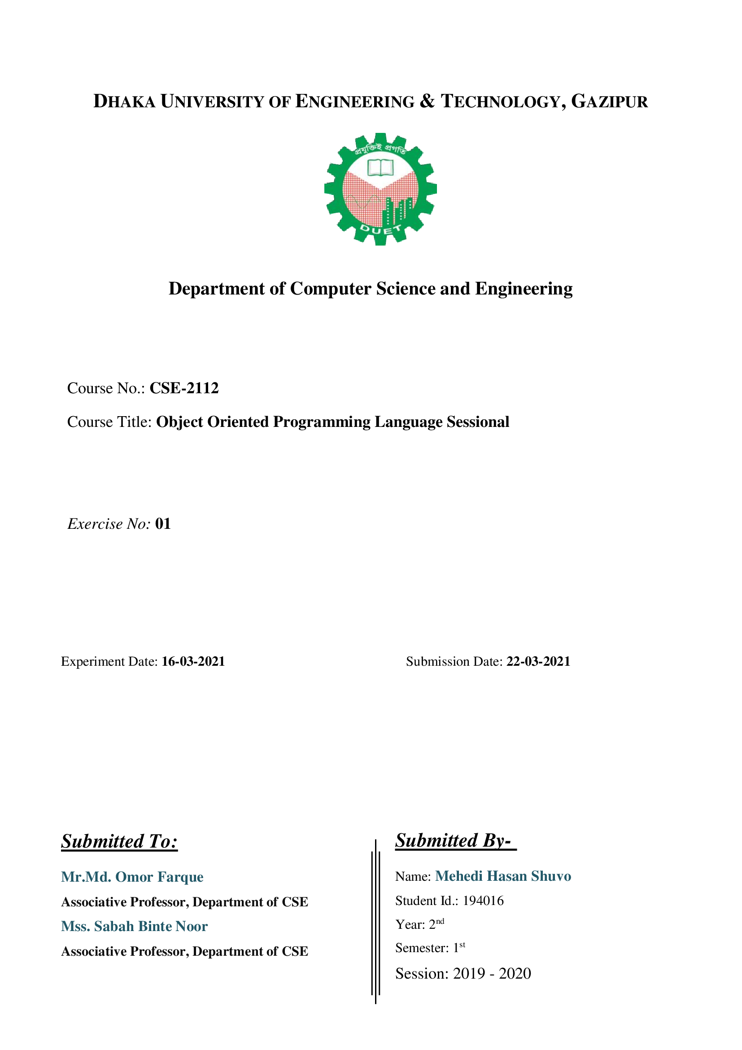

**Problem No:** 01

**Problem Name:** Create a class named “Family” which has three data member size, names, ages and four functions display(), avg(). The display function should print the average age of the family, the names and ages of the family member.

Also Create two objects of the family class and, find the eldest and youngest family member between two families. (you may write other member functions if necessary)

**Solution:**

|  |
| --- |
| #include<iostream>  #include<string>  using namespace std;  class Family  {  public:  int familySizeOne,familySizeTwo;  int familyAgeOne[10],familyAgeTwo[10];  string familyNameOne[10],familyNameTwo[10];  } a,b;  void display(int e,int b[],string c[],int f,int g[],string h[]);  void avg(int e,int b[],int f,int g[]);  int main()  {  cout<<"Enter the Number of members For Family One: ";  cin>>a.familySizeOne;  int c=a.familySizeOne,i;  for(i=0; i<c; i++)  {  cout<<"Name: ";  cin>>a.familyNameOne[i];  cout<<"Age: ";  cin>>a.familyAgeOne[i];  }  cout<<"Enter the Number of members For Family Two: ";  cin>>b.familySizeTwo;  int d=b.familySizeTwo;  for(i=0; i<d; i++)  {  cout<<"Name: ";  cin>>b.familyNameTwo[i];  cout<<"Age: ";  cin>>b.familyAgeTwo[i];  }  display(a.familySizeOne,a.familyAgeOne,a.familyNameOne,b.familySizeTwo,b.familyAgeTwo,b.familyNameTwo);  avg(a.familySizeOne,a.familyAgeOne,b.familySizeTwo,b.familyAgeTwo);  }  void display(int e,int b[10],string c[10],int f,int g[],string h[])  {  cout<<"\nNumber of members: "<<e<<endl;  int i,sum_age=0;  cout<<"Name"<<"\t\t"<<"Age"<<endl;  for(i=0; i<e; i++)  {  sum_age+=a.familyAgeOne[i];  cout<<a.familyNameOne[i]<<"\t\t"<<a.familyAgeOne[i]<<endl;  }  cout<<"Avg age:"<<sum_age/e<<endl;  cout<<"Number of members: "<<f<<endl;  cout<<"Name"<<"\t\t"<<"Age"<<endl;  int sum1_age=0;  for(i=0; i<f; i++)  {  sum1_age+=g[i];  cout<<h[i]<<"\t\t"<<g[i]<<endl;  }  cout<<"Avg age:"<<sum1_age/f<<endl;  }  //Determine Eldest and youngest value  void avg(int e,int b[],int f,int g[])  {  int i,avg,sum=0,max=a.familyAgeOne[0],min=a.familyAgeOne[0];  int sum1=0,max1=g[0],min1=g[0];  for(i=0; i<e; i++)  {  sum=sum+a.familyAgeOne[i];  if(a.familyAgeOne[i]>max)  {  max=a.familyAgeOne[i];  }  if(a.familyAgeOne[i]<min)  {  min=a.familyAgeOne[i];  }  for(i=0; i<f; i++)  {  sum1=sum1+g[i];  if(g[i]>max1)  {  max1=g[i];  }  if(g[i]<min1)  {  min1=g[i];  }  }  }  int last_max,last_min;  if(max>max1)  {  last_max=max;  }  else  {  last_max=max1;  }  if(min>min1)  {  last_min=min1;  }  else  {  last_min=min;  }  cout<<"\nEldest:"<<last_max<<"\t"<<"Youngest:"<<last_min<<"\n";  } |

**Output:**

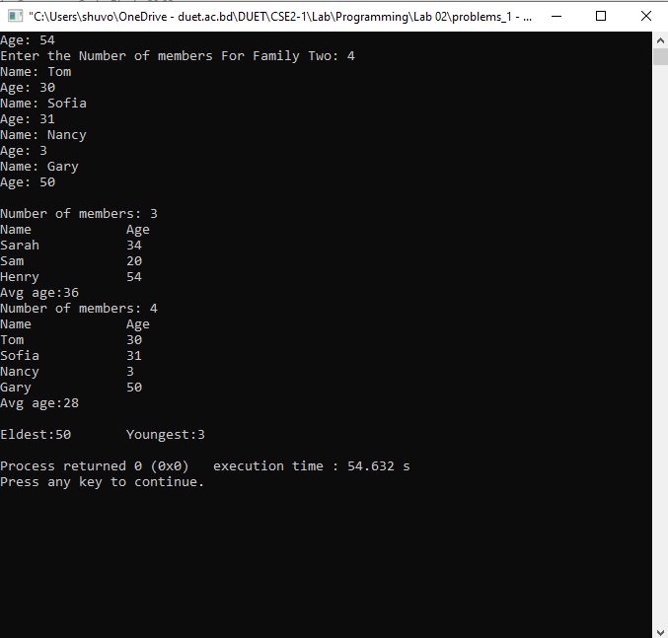

**Problem No:** 02

**Problem Title:** Print the sum, difference and product of two complex numbers by creating a class named 'Complex'. This class should have separate function for each operation.

**Solution:**

|  |
| --- |
| #include<iostream>  using namespace std;  class Complex  {  public:  int real, imaginary;  Complex()  {  }  Complex(int tempReal, int tempImaginary)  {  real = tempReal;  imaginary = tempImaginary;  }  Complex addComp1(Complex C1, Complex C2)  {  Complex temp;  temp.real = C1.real + C2.real;  temp.imaginary = C1.imaginary + C2.imaginary;  return temp;  }  Complex addComp2(Complex C1, Complex C2)  {  Complex temp;  temp.real = C1.real - C2.real;  temp.imaginary = C1.imaginary - C2.imaginary;  return temp;  }  };  int main()  {  Complex C1(9, 5);  cout<<"Complex number 1 : "<< C1.real<< " + i"<< C1.imaginary<<endl;  Complex C2(2, 3);  cout<<"Complex number 2 : "<< C2.real<< " + i"<< C2.imaginary<<endl;  Complex C3;  C3 = C3.addComp1(C1, C2);  cout<<"Sum of complex number : "<< C3.real << " + i"<< C3.imaginary<<endl;  Complex C4;  C4 = C4.addComp2(C1, C2);  cout<<"Difference of complex number : "<< C4.real << " - i"<< C4.imaginary;  return 0;  } |

**Output:**

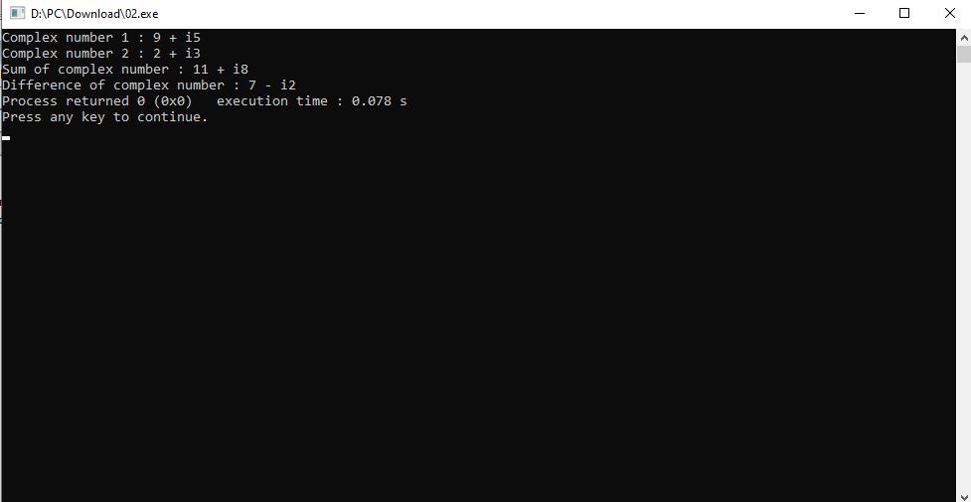

**Problem No:** 03

**Problem Title:** Write a program that would print the information (name, year of joining, salary, address) of three employees by creating a class named 'Employee'. Also, write

* constructor to initialize the values from user
* copy constructor, destructor

**Solution:**

|  |
| --- |
| #include<iostream>  #include<string>  #include<cstdio>  using namespace std;  class Employee  {  public:  string ch;  int year;  string address;  public:  Employee(string st_ch,int st_year,string st_address)  {  ch=st_ch;  year=st_year;  address=st_address;  cout<<ch<<"\t"<<year<<"\t"<<address<<endl;  }  Employee(Employee &obj)  {  ch=obj.ch;  year=obj.year;  address=obj.address;  }  ~Employee()  {  cout<<"destructor"<<endl;  }  };  int main()  {  string ch,address,ch1,address1,ch2,address2;  int year,year1,year2;  cout<<"Enter the first Name:";  cin>>ch;  cout<<"Enter the first Year:";  fflush(stdin);  cin>>year;  cout<<"Enter the first address:";  fflush(stdin);  cin>>address;  cout<<"\nEnter the second Name :";  cin>>ch1;  cout<<"Enter the second Year:";  fflush(stdin);  cin>>year1;  cout<<"Enter the second address:";  fflush(stdin);  cin>>address1;  cout<<"\nEnter the Third Name:";  cin>>ch2;  cout<<"Enter the Third Year:";  fflush(stdin);  cin>>year2;  cout<<"Enter the Third address:";  fflush(stdin);  cin>>address2;  cout<<"\nName"<<"\t"<<"Year"<<"\t"<<"Salary"<<"\t"<<"Address"<<endl;  Employee a(ch,year,address);  Employee b(ch1,year1,address1);  Employee c(ch2,year2,address2);  } |

**Output:**

